**Assignment #1. HTML Basics**

Student: Kyrmyzy Zholekesh

Group: SE-2413

**Part 1. Introduction to HTML**

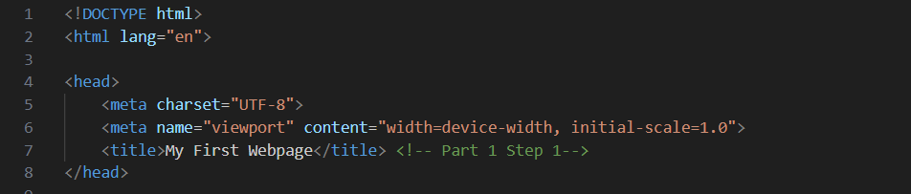

**<!DOCTYPE html>** - Tells the browser “this is an HTML5 page.”

**<html lang="en"> ... </html> -** says the main language is English.

**<head> ... </head> -** This element designates the header portion of your document

**<meta charset="UTF-8">** - Lets the page show any characters (English, Russian, Kazakh, emoji).

**<meta name="viewport" content="width=device-width, initial-scale=1.0">** - Makes the page look good on phones (responsive).

**<title>My First Webpage</title>** **-** Text on the browser tab.

Изображение выглядит как текст, снимок экрана, Шрифт

Содержимое, созданное искусственным интеллектом, может быть неверным.

**<body> ... </body> -**  Everything here is visible on the page.

**<h1>Name is Kyrmyzy</h1>** - Biggest title.

**<h2>SE-2413</h2>** - A smaller heading

**<h3>I am from Aktau. My hobby is watching Korean doramas.</h3>** - Another smaller heading.

**<p> ... </p>** - Paragraph text.

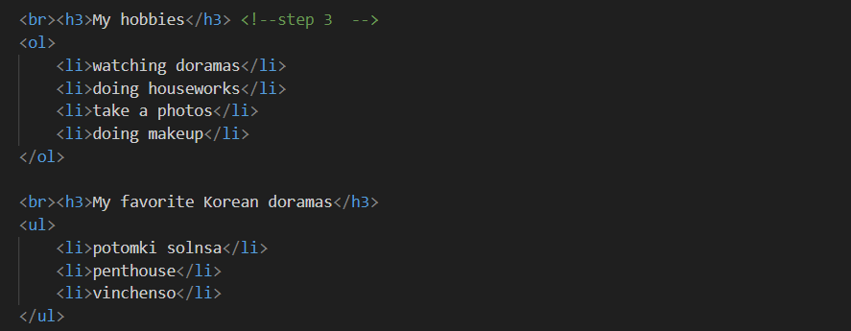

**<ol><li>...</li></ol>** - An ordered (numbered) list.

**<ul><li>...</li></ul>** - Unordered (bulleted) list.

Изображение выглядит как текст, снимок экрана, Шрифт

Содержимое, созданное искусственным интеллектом, может быть неверным.

**<img src="..."> -** Shows a picture from a link.

**<a href="...">Text</a>** - Clickable text that opens YouTube songs.



**<button type="button">Click me!</button> -** A clickable button.

Part 2. Intermediate HTML

Изображение выглядит как текст, снимок экрана, программное обеспечение

Содержимое, созданное искусственным интеллектом, может быть неверным.

**<table border="1">** - Creates a table. → border="1" adds a simple black border around cells.

**<caption>School schedule</caption>** - Adds a title to the table.

**<thead>** - This section is for the “header” of the table. Normally, you put only the header row (<tr> with <th> cells) here.

**<tr>** (table row) - Each <tr> makes a horizontal row.

**<th>** (table header cell) - Like a “title cell”. Text inside is usually bold and centered.  
→ Example: “Subject”, “Day”, “Time”.  
→ Attribute scope="col" means: this header belongs to the whole column.

**<td>** (table data cell) - Normal table cell with data (English, Monday, 8:00).

Изображение выглядит как текст, снимок экрана, программное обеспечение

Содержимое, созданное искусственным интеллектом, может быть неверным.

<table border="1" width="50%"> ө Table with 50% width and border.

<td width="30%"> - Left column (Menu), 30% width.

<td width="30%"> - Right column (Content), 30% width.

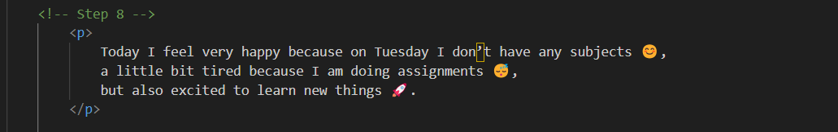<p> ... </p> - A paragraph. Inside the text, you can just type emojis . They are treated like normal characters.

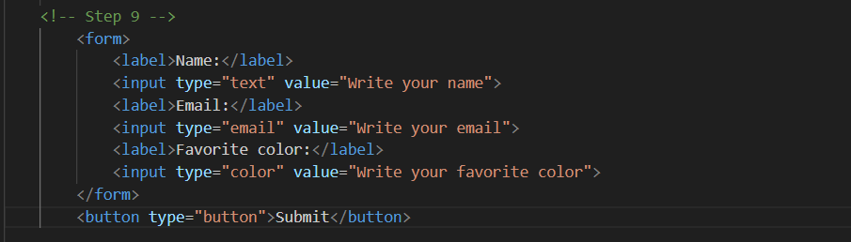

**<form> ... </form> -**  The form tag wraps all input fields and the button. It tells the browser: “this is a form for user input.”

**<label> ... </label> -** A label is the text shown next to an input. It tells the user what to write (Name, Email, etc.).

**type="text" -** normal text field.

**placeholder="Write your name" -** grey hint inside the box until the user types something.

**type="email"** - special field for email. The browser checks if it looks like an email (example@site.com).

**placeholder="Write your email"** - hint text.

**type="color" -** opens a color picker tool.

**value="#ff0000" -** default color is red (#ff0000 is a HEX code for red).

**<button type="submit">Submit</button> -** A button that submits the form.

**type="submit"** means the form will be sent

**Step 10**

[**https://zholekeshkyrmyzy.github.io/Web/**](https://zholekeshkyrmyzy.github.io/Web/)